**THE CHESTERMAN - TOFINO**

Tofino's 2.7-kilometre-long Chesterman Beach got its name from John Chesterman, who was a white settler who acquired grants from the Crown for the area in 1915.

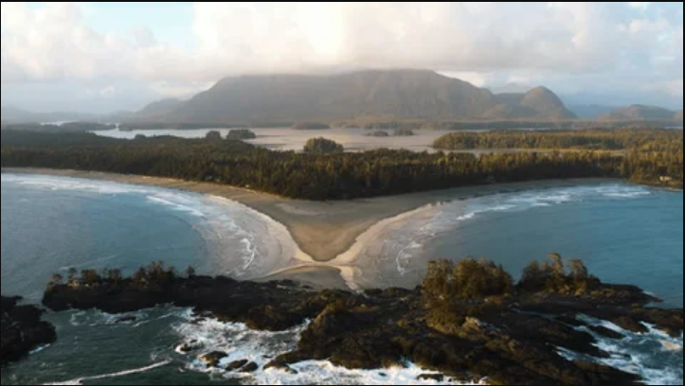North and South Chesterman are connected by over 2.7 kilometers (1.7 mile) of white sand. At low tide, the tombolo (sandspit) connecting Chesterman Beach to Frank Island is exposed and makes for an enjoyable walk.

**Tofino** is a town of approximately 2, 516 residents on the west coast of [Vancouver Island](https://en.wikipedia.org/wiki/Vancouver_Island) in the [Canadian province](https://en.wikipedia.org/wiki/Provinces_and_territories_of_Canada) of [British Columbia](https://en.wikipedia.org/wiki/British_Columbia). The District of Tofino is located at the western terminus of [Highway 4](https://en.wikipedia.org/wiki/British_Columbia_Highway_4) on the tip of the [Esowista Peninsula](https://en.wikipedia.org/wiki/Esowista_Peninsula" \o "Esowista Peninsula) at the southern edge of [Clayoquot Sound](https://en.wikipedia.org/wiki/Clayoquot_Sound). It is situated in the traditional territory of the Tla-o-qui-aht First Nations and is called *Načiks* in the [Nuu-chah-nulth language](https://en.wikipedia.org/wiki/Nuu-chah-nulth_language).